

Faculty of Technology and Engineering
Chandubhai S. Patel Institute of Technology (CSPIT) Department of Computer Science & Engineering
Date:15/08/2026
Laboratory Manual

Academic Year | : | 2026-27 | Semester | : | 3rd
Course code | : | ITUE203 | Course name | : | WEB DEVELOPMENT FRAMEWORKS

Practical – 1:-
Project Initiation, Requirement Analysis, Sitemap, Wireframe, and GitHub Setup
Problem Statement:- Initiate the semester-long StudentHub portal by identifying the problem scope, user roles, key modules, navigation flow, and minimum 10 pages.
Create a sitemap, low-fidelity wireframe, project folder structure, README file, and GitHub repository.
Objective:- To initiate the development of a semester-long StudentHub Portal by analyzing the problem requirements, identifying the target users and their roles, designing the key functional modules, creating a clear navigation flow, and planning a minimum 10-page website. The project also aims to establish a structured development workflow by preparing a sitemap, low-fidelity wireframes, project folder structure, README documentation, and a GitHub repository for version control and collaborative development.

https://github.com/D26CS122/StudentHub
Github Repository link:-
Screenshots:-SiteMap:- 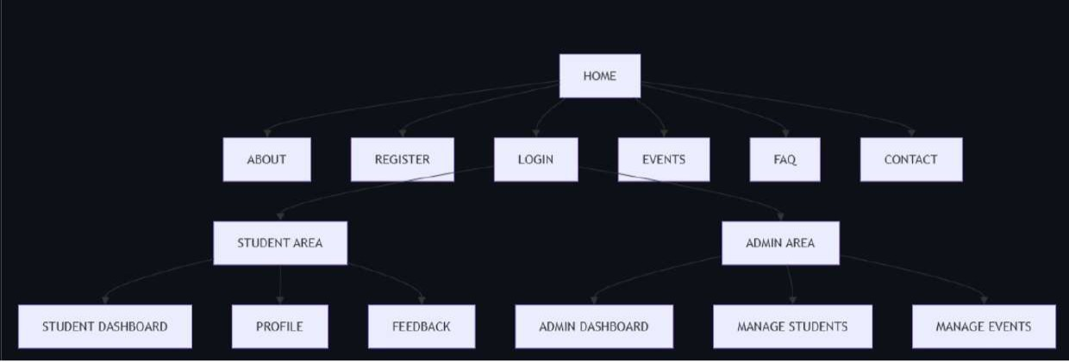

WireFrame:-

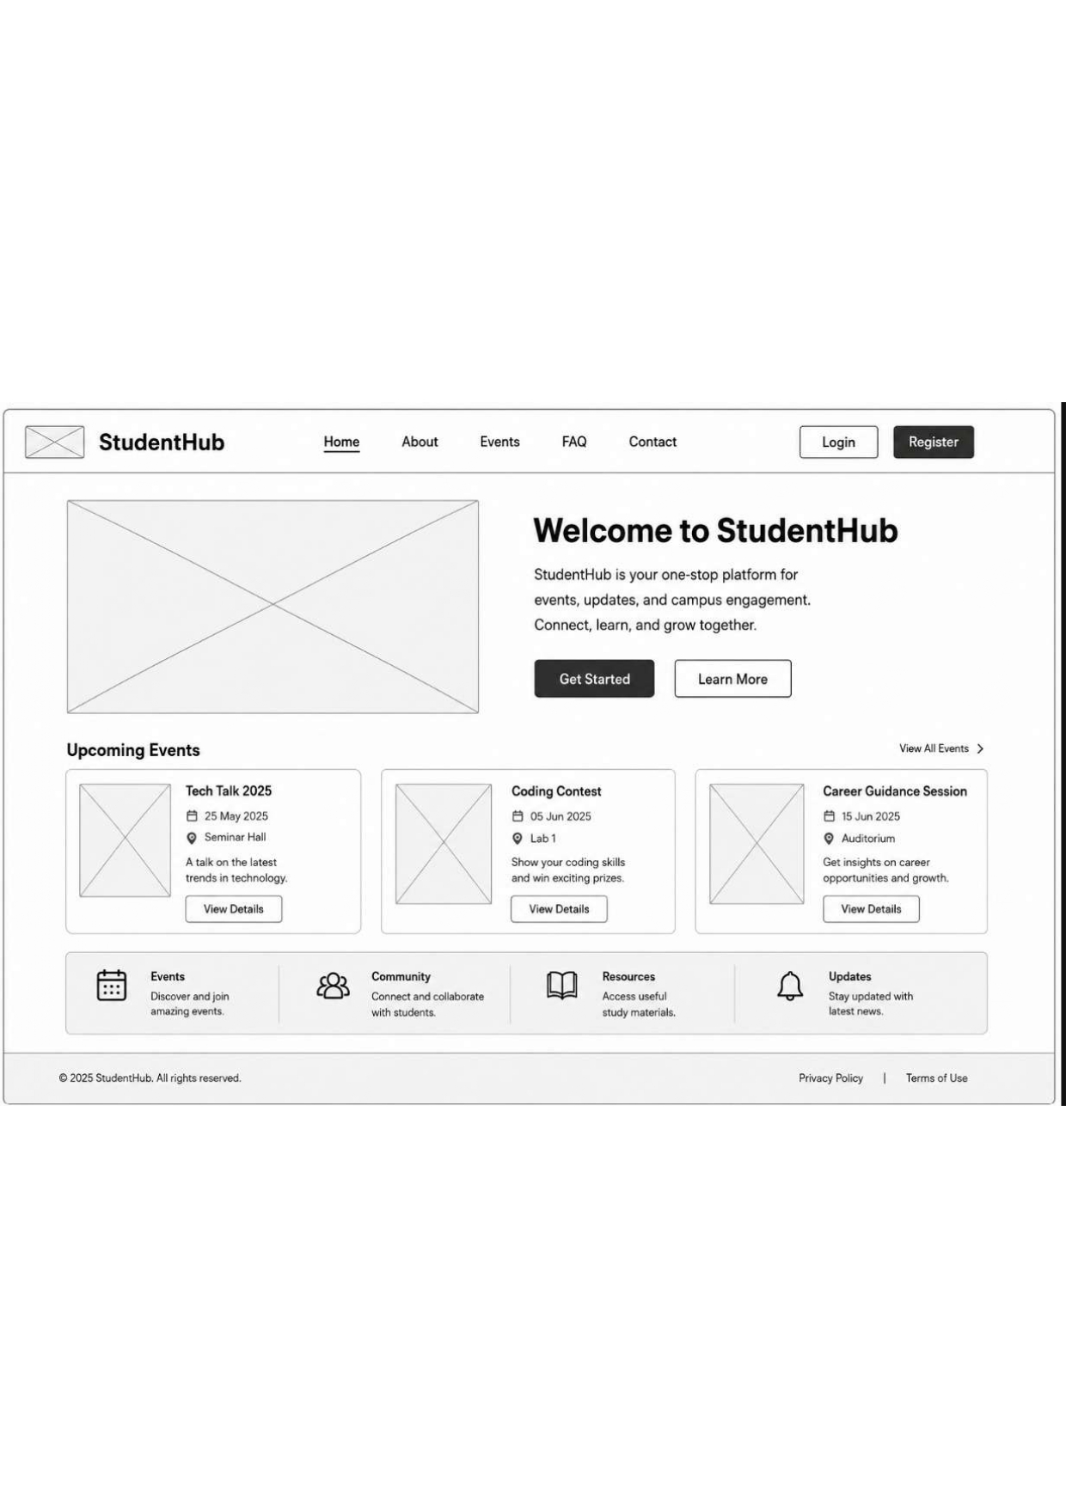

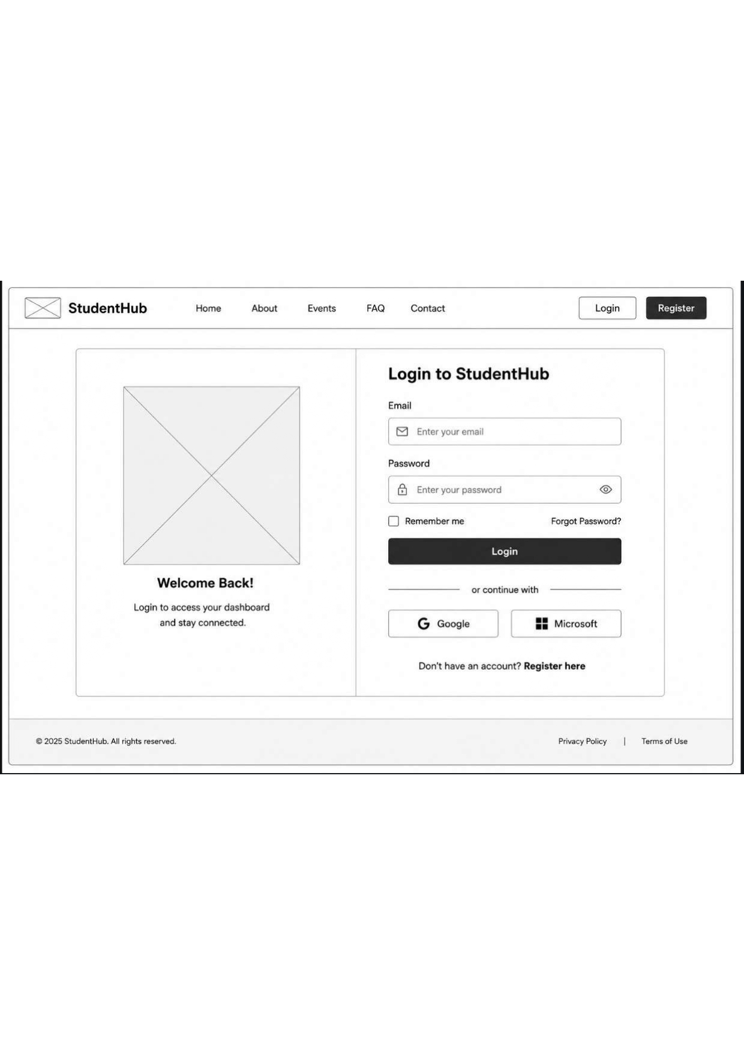

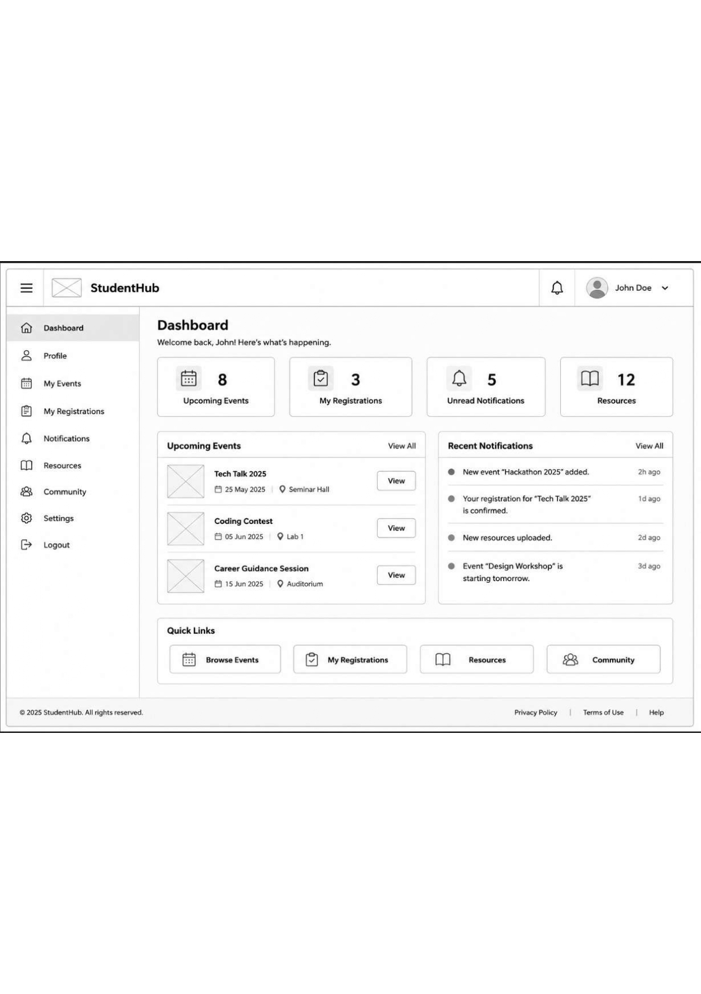
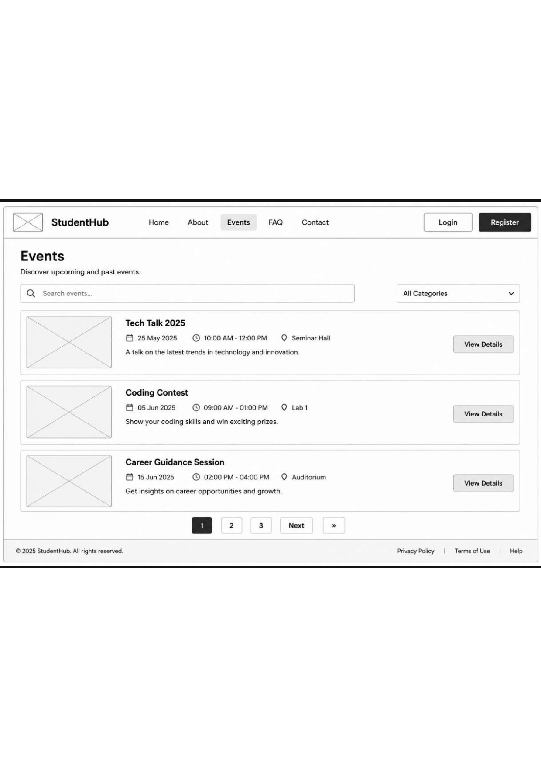

VS Code Files:-

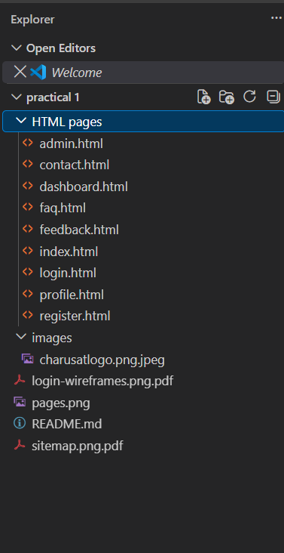

GitHub setup :-
